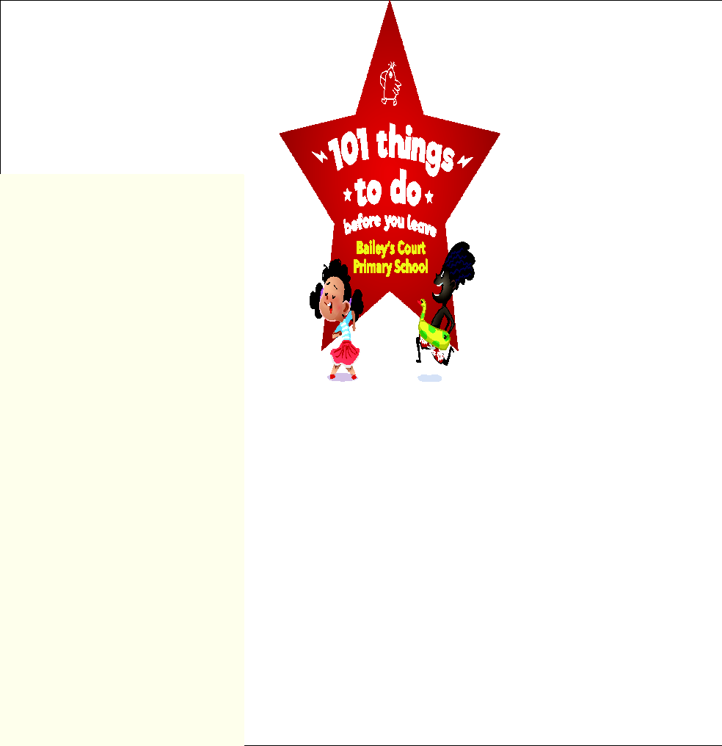

**MY PASSPORT**

**NAME:**

**CLASS:**

**YEAR:**

| **YEAR 5** | | |
| --- | --- | --- |
| **Creativity** | **Photograph / Notes** | **Teacher’s Stamp** |
| **Write a story for a younger child** |  |  |
| **Make a papier-mâché sculpture** |  |  |
| **Make a ‘show-stopper’ cake** |  |  |
| **Write a song** |  |  |
| **Take part in a dance as part of a group** |  |  |
| **Wild Card** |  |  |
| **Challenge** | **Photograph/Notes** | **Teacher’s Stamp** |
| **Take part in a debate** |  |  |
| **Camp outside under canvas or in a den** |  |  |
| **Learn to count up to ten in three languages** |  |  |
| **Take part in a sporting competition or match** |  |  |
| **Make and launch an air-powered rocket** |  |  |
| **Wild Card** |  |  |
| **Curiosity** | **Photograph / Notes** | **Teacher’s Stamp** |
| **Go bird watching** |  |  |
| **Find out about your local area before you were born** |  |  |
| **Visit a factory to find out how something is produced** |  |  |
| **Try food from every continent** |  |  |
| **Identify five local trees and plants** |  |  |
| **Wild Card** |  |  |
| **Caring** | **Photograph/Notes** | **Teacher’s Stamp** |
| **Raise awareness of an environmental issue (e.g.poster/video)** |  |  |
| **Make a bird feeder** |  |  |
| **Grow your own vegetables and eat them** |  |  |
| **Do a good deed for an older relative** |  |  |
| **Hold a sponsored event** |  |  |
| **Wild Card** |  |  |
| **Fun** | **Photograph / Notes** | **Teacher’s Stamp** |
| **Build a scarecrow** |  |  |
| **Learn to moon-walk** |  |  |
| **Go to a disco** |  |  |
| **Have a sleepover** |  |  |
| **Use chopsticks** |  |  |
| **Wild Card** |  |  |
| **If you have any suggestions, ideas or comments about our ‘101 things’ project, please do let us know. We hope you have enjoyed taking part.** | | |