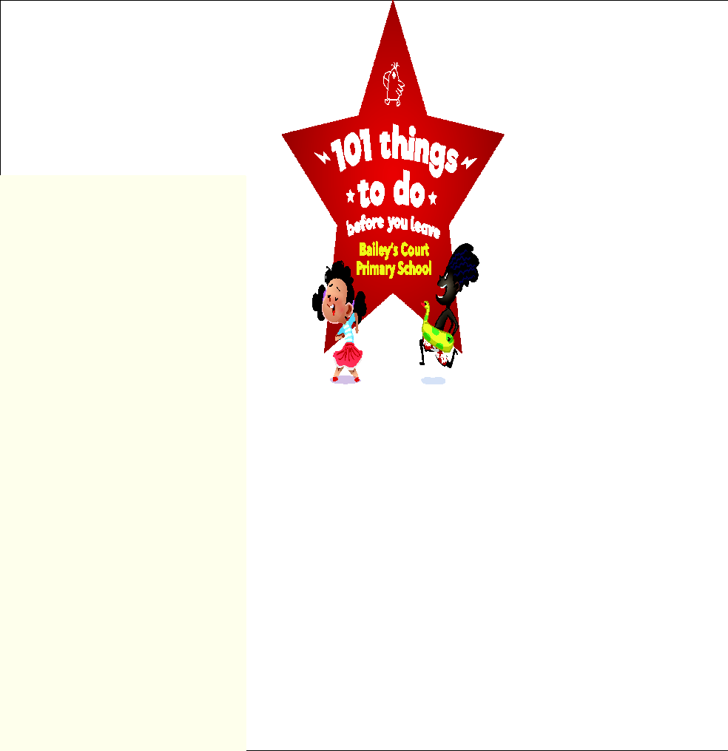

**MY PASSPORT**

**NAME:**

**CLASS:**

**YEAR:**

| **YEAR 4** | | |
| --- | --- | --- |
| **Creativity** | **Photograph / Notes** | **Teacher’s Stamp** |
| **Write and perform a poem** |  |  |
| **Visit the theatre** |  |  |
| **Use a camera to take a series of pictures to tell a story** |  |  |
| **Make a sculpture** |  |  |
| **Play a tune on an instrument** |  |  |
| **Wild Card** |  |  |
| **Challenge** | **Photograph/Notes** | **Teacher’s Stamp** |
| **Skim stones** |  |  |
| **Learn to sew on a button** |  |  |
| **Build a bridge and test its strength** |  |  |
| **Use a map to plan and go on a walk** |  |  |
| **Swim a length of a swimming pool** |  |  |
| **Wild Card** |  |  |
| **Curiosity** | **Photograph / Notes** | **Teacher’s Stamp** |
| **Visit a place a worship** |  |  |
| **Visit a local landmark** |  |  |
| **See the sun set and then rise** |  |  |
| **Visit a place underground** |  |  |
| **Make your own honeycomb** |  |  |
| **Wild Card** |  |  |
| **Caring** | **Photograph/Notes** | **Teacher’s Stamp** |
| **Plant a garden that will attract insects** |  |  |
| **Make a dessert for your family on your own** |  |  |
| **Hold and find out about an exotic animal** |  |  |
| **Spend time over a week picking up litter in your community** |  |  |
| **Write a letter to bring happiness to someone you love** |  |  |
| **Wild Card** |  |  |
| **Fun** | **Photograph / Notes** | **Teacher’s Stamp** |
| **Make up your own game and teach it** |  |  |
| **Swim outside** |  |  |
| **Take part in a water fight** |  |  |
| **Make an ice cream sundae and eat it** |  |  |
| **Take a trip to the cinema** |  |  |
| **Wild Card** |  |  |
| **If you have any suggestions, ideas or comments about our ‘101 things’ project, please do let us know. We hope you have enjoyed taking part.** | | |