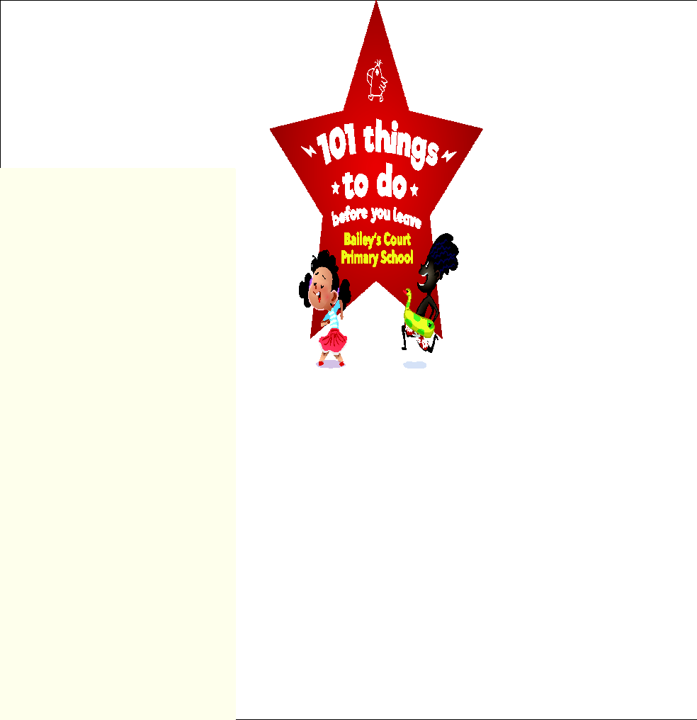

**MY PASSPORT**

**NAME:**

**CLASS:**

**YEAR:**

| **YEAR 1** | | |
| --- | --- | --- |
| **Creativity** | **Photograph / Notes** | **Teacher’s Stamp** |
| **Decorate some biscuits** |  |  |
| **Make a puppet** |  |  |
| **Create a comic strip** |  |  |
| **Make a Chinese lantern** |  |  |
| **Make a giant sandcastle** |  |  |
| **Wild Card** |  |  |
| **Challenge** | **Photograph/Notes** | **Teacher’s Stamp** |
| **Learn a dance** |  |  |
| **Ride a bike without stabilisers** |  |  |
| **Send a postcard** |  |  |
| **Build a den outside** |  |  |
| **Learn to skip** |  |  |
| **Wild Card** |  |  |
| **Curiosity** | **Photograph / Notes** | **Teacher’s Stamp** |
| **Discover what is in a pond** |  |  |
| **Go on a hunt for some insects** |  |  |
| **Try different foods which contain herbs/spices** |  |  |
| **Visit an historical building** |  |  |
| **Make a fizzing volcano** |  |  |
| **Wild Card** |  |  |
| **Caring** | **Photograph/Notes** | **Teacher’s Stamp** |
| **Make a home for an insect** |  |  |
| **Plant something and watch it grow** |  |  |
| **Learn to wash up** |  |  |
| **Help to do a job in the garden** |  |  |
| **Make a gift for a special person** |  |  |
| **Wild Card** |  |  |
| **Fun** | **Photograph / Notes** | **Teacher’s Stamp** |
| **Play Pooh Sticks** |  |  |
| **Dress up as a book character** |  |  |
| **Lick out a bowl** |  |  |
| **Play in the mud and get dirty** |  |  |
| **Build a snow man** |  |  |
| **Wild Card** |  |  |
| **If you have any suggestions, ideas or comments about our ‘101 things’ project, please do let us know. We hope you have enjoyed taking part.** | | |