charging and remissions policy

Issue 7

September 2024

Approved by: | 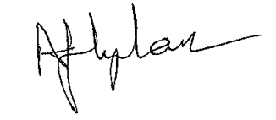
 | Head Teacher  Bailey’s Court Primary School | Date: September 2024
Authorised by: | 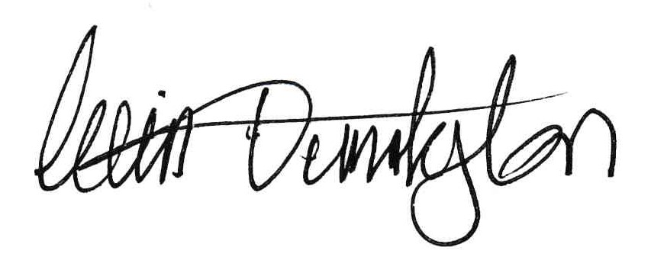
 | Chair of Full Governing Body  Bailey’s Court Primary School | Date: Septmber 2024
Review Date: | September 2026

CONTENTS

1 purpose of the policy 2
2 consultation process 2
3 voluntary contributions 2
4 optional extras 2
5 Individual Instrumental Tuition 2
6 Charging in Kind 2
7 Examination Fees 3
8 Other Activities 3
9 Outside Organisations 3
10 Lettings 3
11 General 3
12 refunds 3
13 damage, loss of equipment 3

CHANGE RECORDS SHEET

Issue No. | Date | Summary of Change | Amended by
1 | March 2012 | Original policy document. | D Hickson
2 | November 2014 | Policy reviewed. Minor changes have been made and are highlighted in the left hand margin. | D Hickson
3 | June 2016 | Policy reviewed: amendments made | S-J Cannings
4 | September 2018 | Policy reviewed: amendments made | M Telfer
5 | September 2020 | Policy reviewed | A Lynham
6 | September 2022 | Policy reviewed | A Lynham
7 | April 2024 | Policy reviewed and amendments made on recommendation of Internal Audit | S-J Morris
8 | September 2024 | Policy reviewed | A Lynham

SUMMARY
This policy should be read in conjunction with all other school policies. If you require further details of this policy then please refer to the Head Teacher or Deputy Head Teacher.
This policy will be reviewed every two ears.

REFERENCE DOCUMENTS
[1] Lettings Policy.
[2] Financial Procedures Guideline.
[3] Management of School Trips and Visits
[4] After School and Breakfast Club Information Sheets

MAIN DOCUMENT

purpose of the policy
The governing body of Bailey’s Court Primary School recognises the valuable contribution that school and extra-curricular activities, including clubs, theatre groups, trips and residential experiences make for our students.
The governing body aims to promote and provide such activities as part of a broad and balanced curriculum for all students along with additional extra-curricular activities.

consultation process
The policy was developed in consultation with staff and governors.

voluntary contributions
The governing body reserves the right to request voluntary contributions for the benefit of the school or any school activities. Where a request is made for a voluntary contribution from parents for an activity, the school will advise parents at the outset and of the basis on which places will be allocated. For any such activity parents are under no obligation to make any contribution, but if insufficient contributions are received to cover the cost of any activity, then that activity may be cancelled. If a parent is unwilling or unable to pay, their child will still be given an equal chance to go on the visit.

optional extras
Charges may be made for some activities that are known as “optional extras”, i.e. school camp, events during special school organised days and enhanced activities.
The governors are agreed that parents should be asked to make 100% contributions towards the cost of these activities. Families on a low income can request support from the governors as detailed below. Any support that is offered to families by the governors will be subsidised by the school and not included in the overall costs of the activity.
Families of a student that is in receipt of Free School Meals may request for support towards the cost of these activities. The governing body will consider offering support of up to 25%, depending on the circumstances of the family.
There may be occasions where the above criteria are not considered to be appropriate and the application will be dealt with on an individual basis.
Requests for support should be passed to the School Business Manager, along with supporting documentation. This request may need to be discussed in confidence by the Finance & Resources Committee; at no time during the governors’ discussion will names be issued by the School Business Manager.

Individual Instrumental Tuition
The governing body has approved a charge for non-curricular instrumental lessons. To enable the cost to be kept to a minimum the governing body has also approved an annual subsidy from the school budget to minimise the cost. The costs will be calculated for individual or group lessons and will be reviewed on an annual basis.
Where the parents of a student are in receipt Free School Meals, families may apply in writing for support; the governing body will consider offering support of 50% towards the cost of instrumental lessons.

BREAKFAST AND AFTER SCHOOL CLUB

The governing body has approved a charge for Bailey’s Court to provide wrap around care before and after school for pupils attending the school. A reduced rate is available for younger siblings when the older sibling pays the full session price and children in receipt of pupil premium are eligible for free breakfast club places. Charges for both clubs are reviewed on an annual basis by the governing body, and prices may be increased due to staffing costs, food costs etc. Payment in expected in advance but any arrears are chased up on a monthly basis. Any payment by childcare vouchers are reconciled on a termly basis

SCHOOL DINNERS
Bailey’s Court runs it’s own kitchen and charges a set amount for KS2 pupils school donners and staff dinners. Charges are reviewed on an annual basis by the governing body, and prices may be increased due to staffing costs, food costs etc. KS1 costs are covered by Universal Free School Meals income and children in receipt of Free School Meals are covered by the pupil premium grant. Payment in expected in advance but any arrears are chased up on a monthly basis.

Charging in Kind
The cost of materials, ingredients, equipment (or the provision of them by parents) for the following subjects: art; craft, and design and technology will be provided by the school. Parents may be asked to contribute for cooking ingredients for cooking sessions, although the school will also contribute for curriculum sessions.

Examination Fees
Where a student has not been prepared for an examination by the school, the governing body would not pay for the cost of entering the student for the examination.

Other Activities
The governing body may request a contribution to support other activities taking place during school hours e.g. theatre groups.

Outside Organisations
The Governing Body may permit outside organisations to charge parents when such an organisation is acting independently of the school or the local authority.

Lettings
The Finance Committee will review lettings charges on an annual basis with invoices being issued at the end of each month.

General
The governing body may, from time to time, amend the categories of activity for which a charge may be made.
Nothing in this policy statement precludes the governing body from inviting parents to make a voluntary contribution towards the cost of providing education for students.

refunds
Should a visit/activity be cancelled by the school then contributions made by parents will be refunded in full.
In the event that a parent no longer wishes their child to participate in an activity or a student is unable to attend a day trip due to illness the parent can request a refund. Where a deposit/advance payment has been paid the school will only refund for the costs not incurred by the school. It is unlikely that the cost of transport or any pre-paid tickets/entrance fees can be refunded.
If a student is unable to attend a residential trip because of ill health or an accident and the school is unable to obtain a refund from the travel company, then a letter will be required from their doctor with details of the illness/accident in order to make a claim through the insurance policy.

damage, loss of equipment
The governors wish to make it clear that pupils and staff are expected to treat all school property with care and respect. Should any non-accidental damage be caused by a pupil or member of staff, or a book or equipment lost while in the possession of a student or member of staff, then the economic cost of repairing, making good or purchasing a replacement will be the responsibility of the parents of that pupil or the member of staff concerned.

