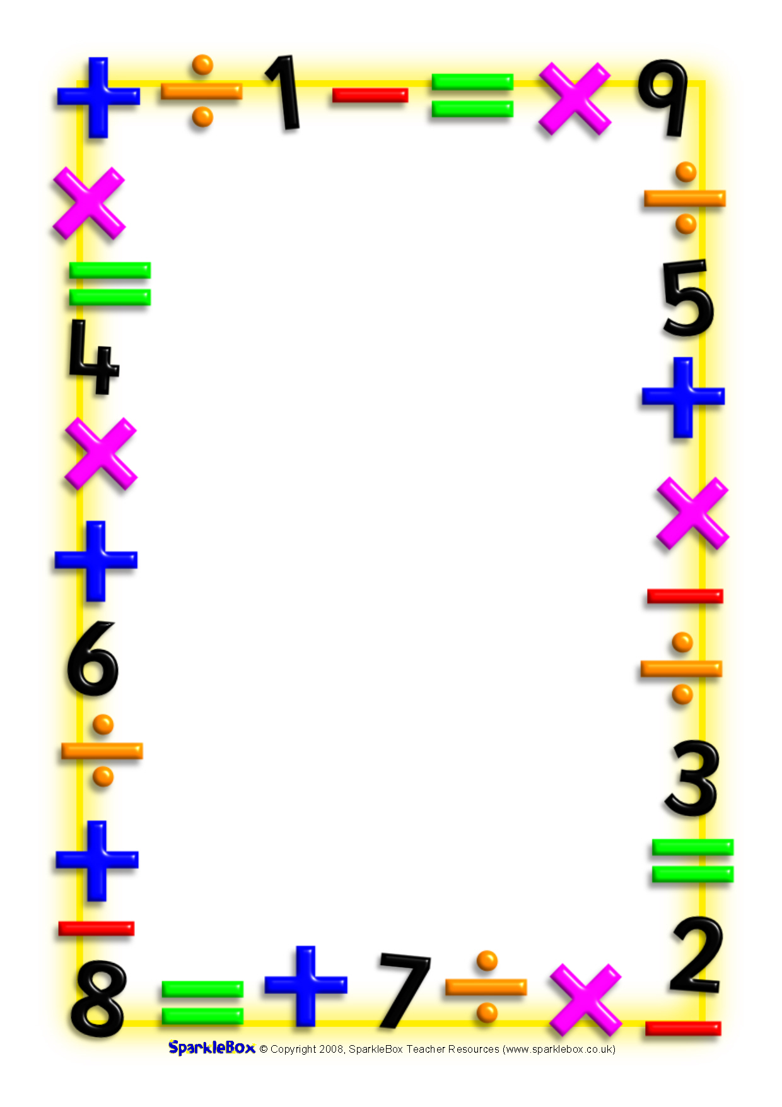

Bailey’s Court
Calculation Policy

Please note that this is the progression we follow across the school; however, some stages may be taught alongside each other.
Addition
Stages | Examples
Stage 1  Use of objects | 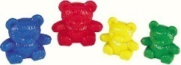  +  2 + 4 = 6
Stage 2  Practical representation using numicon and 5 and 10 frames. | 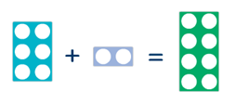  6 + 2 = 8
Stage 3  Use of pictorial representations | 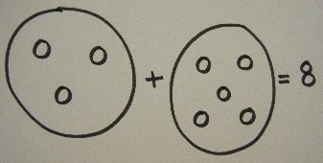  3 + 5 = 8
Stage 4  Adding ones on a number line. | 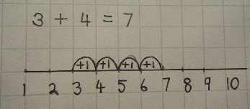
Stage 5  Adding tens and ones on a number line and with sticks and dots. | 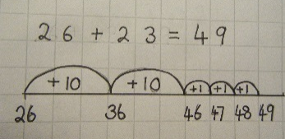  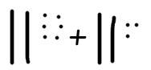
Stage 6  Adding multiples of tens and groups of ones on a number line | 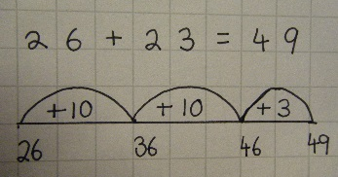
Stage 7  Adding tens and ones on a number line bridging 10 and with sticks and dots. | 28+25= 53  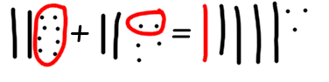
Stage 8  Addition through partitioning | 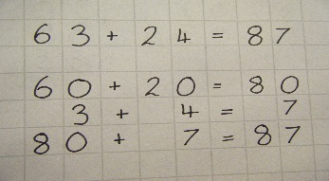
Stage 9  Column addition  (without bridging) | 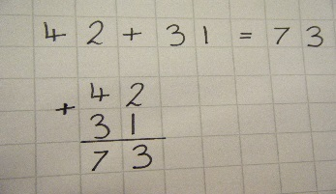
Stage 10  Column addition  (bridging) | 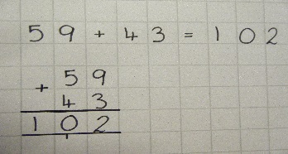
Stage 11  Column addition involving decimals | 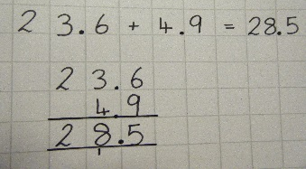

Subtraction
Stages | Examples
Stage 1  Use of objects | 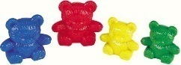  -  6 - 4 = 2
Stage 2  Practical representation using numicon and 5 and 10 frames. | 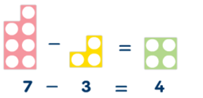
Stage 3  Use of pictorial representation | 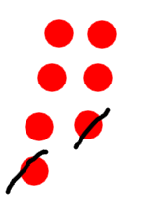7-2=5
Stage 4  Counting back on a number line in ones | 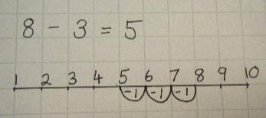
Stage 5  Counting back on a number line in tens and ones and subtracting using sticks and dots. | 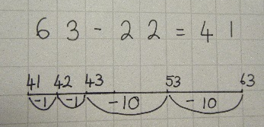  35-12=23  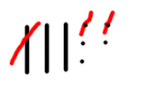
Stage 6  Counting back multiples of tens and groups of ones  (without going over the 10s) | 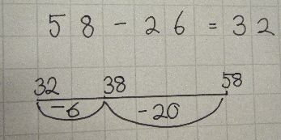
Stage 7  Use of a number line to support going over the 10s and using sticks and dots. | 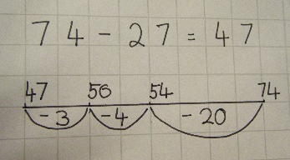  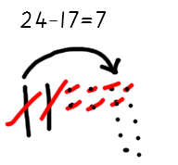
Stage 8  Column subtraction  (without decomposition) | 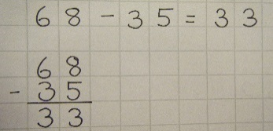
Stage 9  Column subtraction  (with decomposition) | 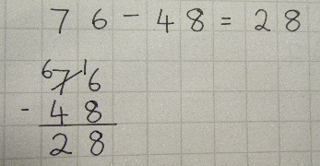
Stage 10  Column subtraction involving decimals | 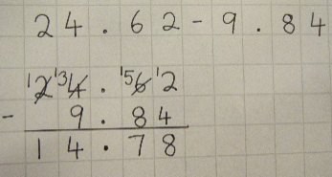

Multiplication
Year 1 | 2x 5x 10x
Year 2 | 3x 4x
Year 3 | 6x 7x 8x 9x
Year 4 | 11x 12x
Year 5/6 | Recall multiplication facts for all tables

Stages | Examples
Stage 1  Use of objects | 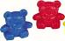  3 x 2= 6
Stage 2  Use of pictorial representations | 3 x 6= 18
Stage 3  Practical representation using numicon | 5x3= 15
Stage 4  Use of arrays | 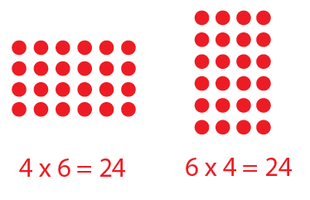
Stage 5  Grid method | 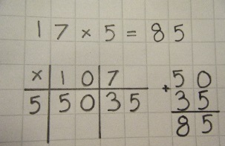
Stage 6  Expanded column multiplication  (TOxU) | 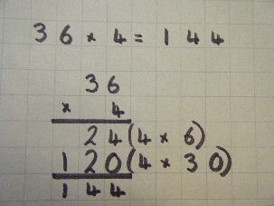
Stage 7  Expanded column multiplication  (TOxTO) | 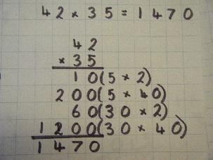
Stage 8  Short Multiplication  (TOxU) | 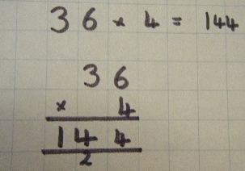
Stage 9  Long Multiplication  (TOxTO) | 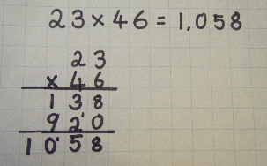
Stage 10  Short multiplication using decimals | 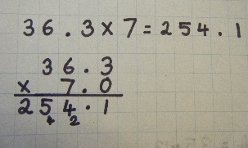

Division
Stages | Examples
Stage 1  Sorting objects into groups | 4 ÷ 2= 2
Stage 2  Practical representation using numicon | 6 ÷ 3 = 2
Stage 3  Pictorial representation | 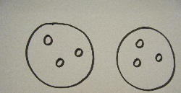  6÷2=3
Stage 4  Divider spider | 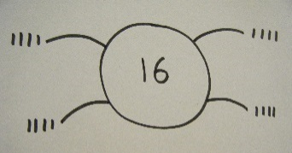  16 ÷ 4= 4
Stage 5  Chunking  (no remainders) | 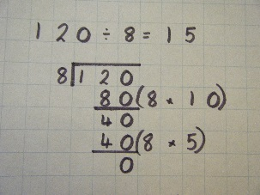
Stage 6  Chunking  (remainders) | 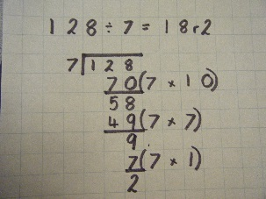
Stage 7  Bus stop  (no remainders) | 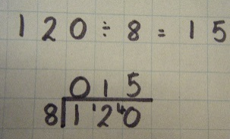
Stage 8  Bus stop  (remainders) | 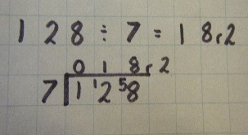
Stage 9  Bus stop  (decimals) | 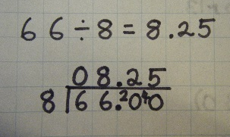
Stage 10  Long division | 